

OPERATING SYSTEM LAB

TAYYABA REHMAN

49690

Lab task 2

1. Rename file atomic-notes with at-notes in the books directory.

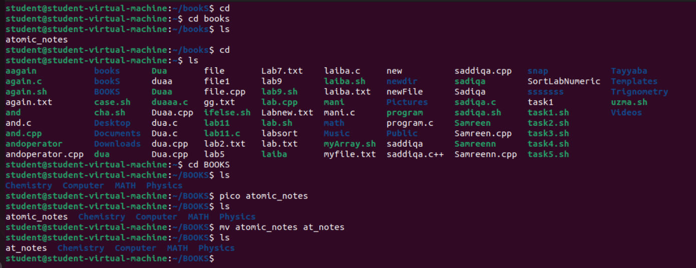

1. Copy this file to sub-directory nuclear under the directory physics.

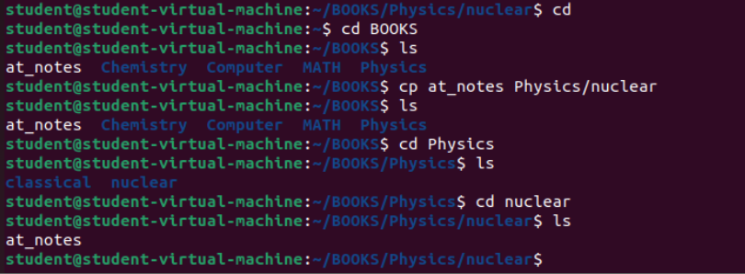

1. Permissions:

* Removed Write(w) permission for owner (user) from file result.comp.

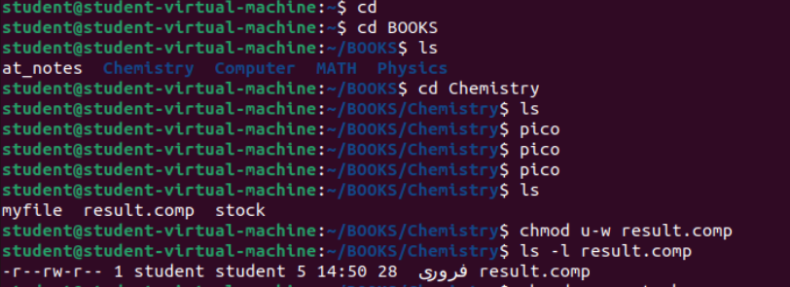

* Group and other get execute access for file stock.



* Set group access for reading(r) and execute(x) of myfile.



1. Create a directory called l**ab4** and create three files say quiz, report and viva inside the directory

## Now try to set the following rights;

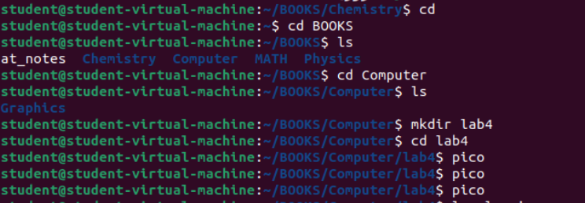

## -rw- r-- r- quiz

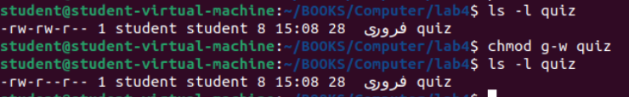

* -**rw- -w- r- - report**

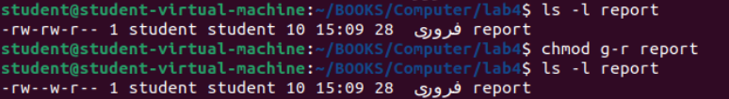

## -rwx rwx r-x viva

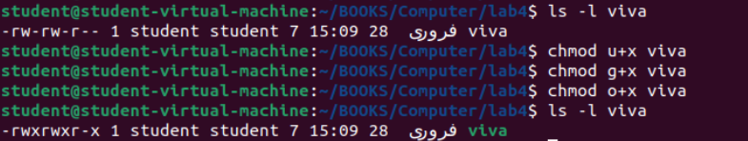

Also try to change access permission of **lab4** directory as well and see how it affects.

